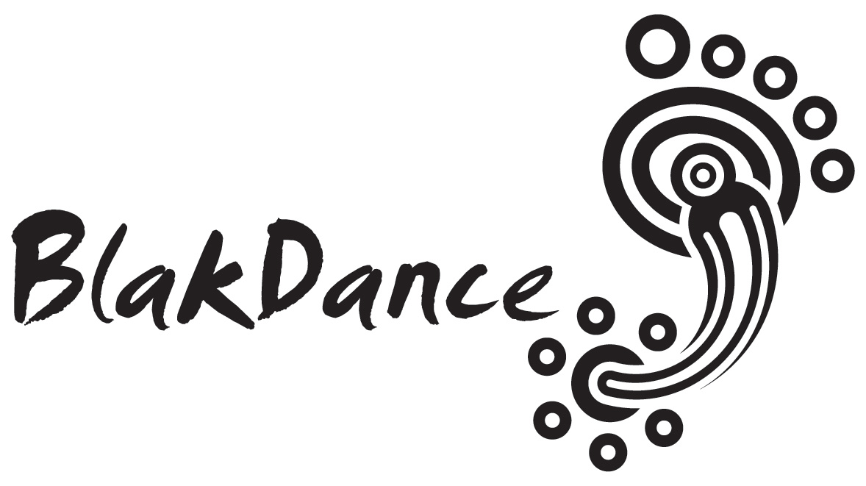

BLAKDANCE
Trainee Producer
POSITION DESCRIPTION

BlakDance:
- Is indigenous led
- Has an innovative and culturally driven governance structure (Elders, Peers, Members, Board, Management)
- Is the trusted source of Indigenous dance advocacy and support in Australia
- Plays a critical role in brokering partnerships between our dance communities and presenters, policy makers, audiences, and stakeholders
- Provides Indigenous dance leadership
As the national peak body for Indigenous dance in Australia, we are here to serve our dance communities by supporting their needs through programs and advocacy. BlakDance’s programs are designed through consultation with our communities to address issues in their regions.
Trainee Producer (Flexible Part Time)
About the Role

The Trainee Producer position is aimed to provide intensive on-the-job skills development and relationship building opportunities for an emerging Indigenous producer. The position aims to support the early career development of an Indigenous producer with a specific interest in working with the dance form.

This position would be ideal for project managers who want to specialise in dance based projects or for artists with good administrative skills to build pathway into arts administration and leadership through the development of relevant skills, industry knowledge and peer to peer working relationships.

The Trainee Producer will have the opportunity to produce stand alone components of the BlakDance programs and initiatives as well as work collaboratively with the core BlakDance team in undertaking strategic programs across BlakDance as well as with BlakDance partners and stakeholders.

Please submit your expression of interest by filling the below form below

If you would like to speak with a BlakDance team member about the position please get in contact with Jane Fuller on jane.fuller@blakdance.org.au

Expressions of Interest close at midnight on 21 July 2017.

Name:

Phone:

Email:

Please provide some information about yourself

Please describe your relationship to dance and the arts

Please describe what skills and opportunities you hope to attain at the end of this position

Please upload your CV here or send it through to Jane Fuller on jane.fuller@blakdance.org.au

Selection Criteria

- A general knowledge and passion for the arts, with a specific interest in Indigenous dance
- Intermediate skills in MS Word and Excel
- Organisational and time management skills with the ability to multi task and meet deadlines
- Have excellent communication and conflict resolution skills
- High level written, verbal and interpersonal communication skills

Applicants must:

- Identify as Aboriginal or Torres Strait Islander
- Be over the age of 18
- Hold a particular interest in Indigenous dance

Formal qualifications are not relevant to this position
This position will have an initial 3 month period of probation

